090611 PMRNRD June Bd Report 6/11/09.doc

Natural Resources Conservation Service (NRCS)
Report To
Papio-Missouri River NRD Board
June 11, 2009
Neil Jensen, Resource Conservationist

EQIP UPDATE

The initial EQIP allocation for the Papio-Missouri River NRCS is $208,000. There are 118 total applications for $1,617,000

EQIP General Applications
- 80 Terrace Applications (1 includes continuous no-till) totaling $1,025,000
- 18 Livestock Applications for $150,000
- 13 Grade Stabilization Structures Applications for $300,000
- 2 Irrigation Applications for $60,000

The next 2 categories are funded from NHQ and/or State funds:

Organic Agriculture
- 2 Applications for $65,000 (1 includes terraces)

Forestry Initiative
- 3 Applications for $17,000

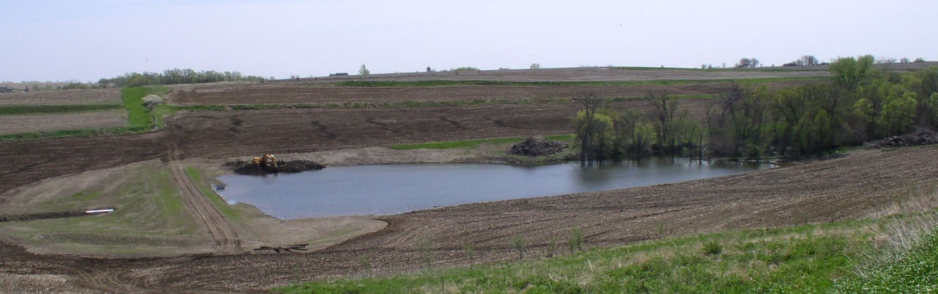
Grade Stabilization Structure recently built in Washington County using NRD CAP funds.
COMPLIANCE REVIEWS

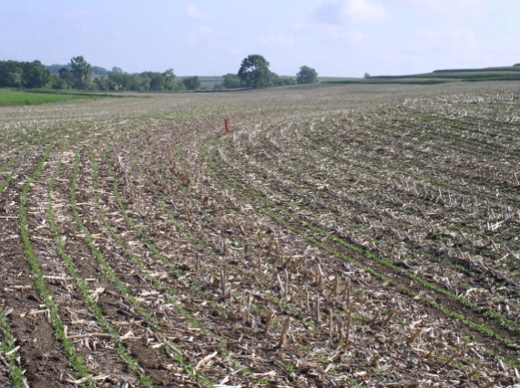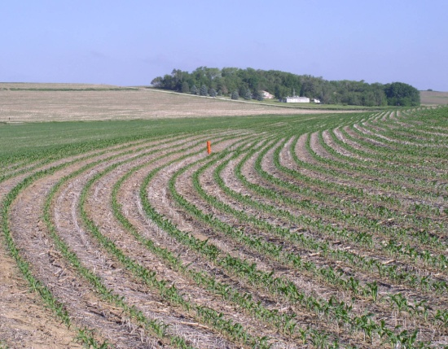

Continuous no-till is a common site during compliance reviews. No-till combined with terraces and underground outlets provides for excellent erosion control. Approximately 45% of the Washington County cropland is continuous no-till.

CONSERVATION RESERVE PROGRAM

52 CRP contract holders have been offered to extend their CRP contract for 5 years. NRCS will be assisting landowners with updating their contracts.

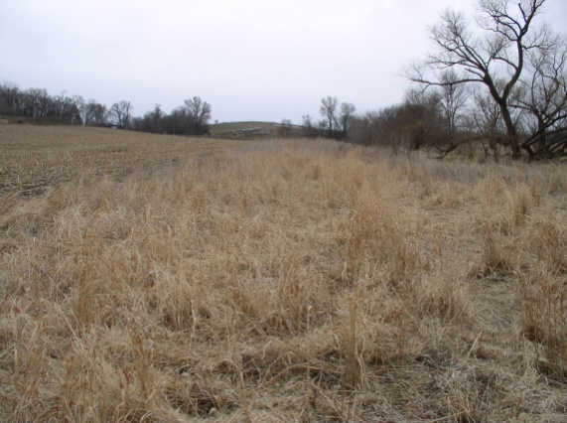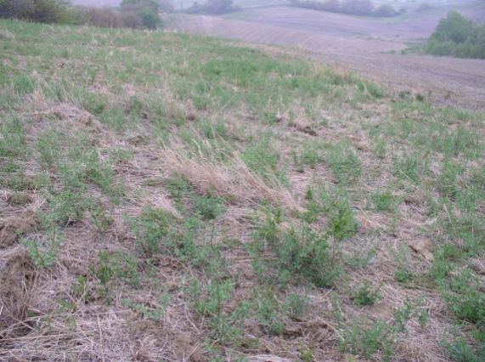

Filter Strips and Field Borders provide excellent wildlife habitat, erosion control and improve water quality.
WETLAND RESERVE PROGRAM

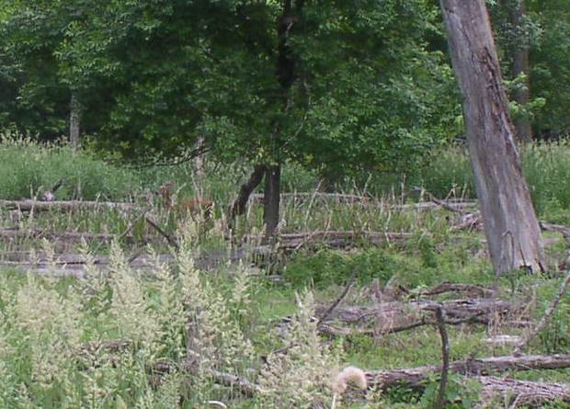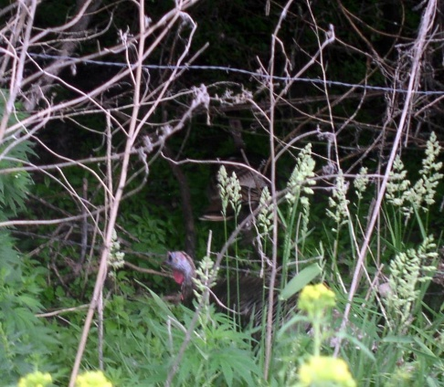

2 WRP applications were recently approved in Washington County. In addition to providing habitat for waterfowl, upland game animals also benefit.

ARBOR DAY CELEBRATION IN BLAIR

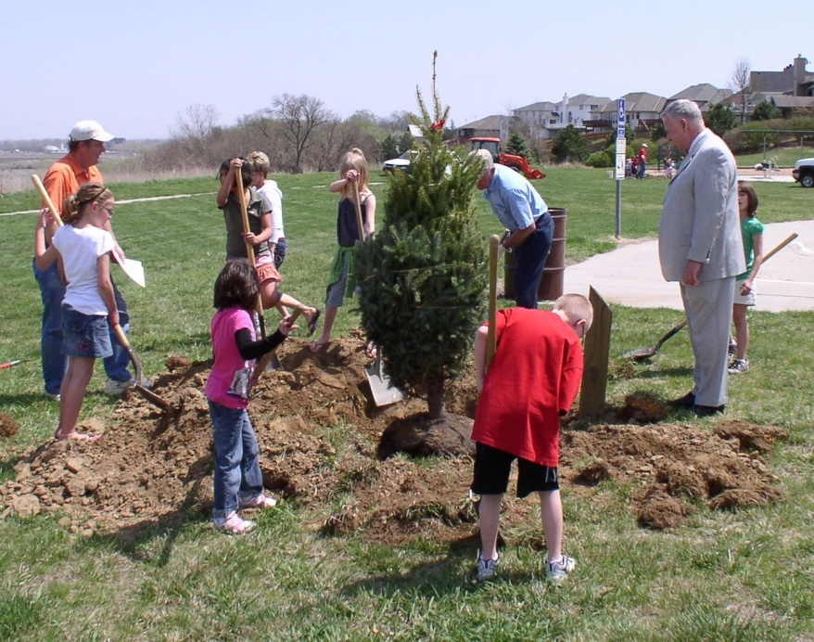

Mayor Jim Realph inspects the progress of one of three trees planted by a Blair second grade class. Each student receives a tree, donated by the Papio-Missouri River NRD, to take home and plant.

________________________________________________________________________

USDA is an Equal Opportunity Provider and Employer

The U.S. Department of Agriculture (USDA) prohibits discrimination in all its programs and activities on the basis of race, color, national origin, age, disability, and where applicable, sex, marital status, familial status, parental status, religion, sexual orientation, genetic information, political beliefs, reprisal, or because all or a part of an individual's income is derived from any public assistance program. (Not all prohibited bases apply to all programs.) Persons with disabilities who require alternative means for communication of program information (Braille, large print, audiotape, etc.) should contact USDA's TARGET Center at (202) 720-2600 (voice and TDD). To file a complaint of discrimination write to USDA, Director, Office of Civil Rights, 1400 Independence Avenue, S.W., Washington, D.C. 20250-9410 or call (800) 795-3272 (voice) or (202) 720-6382 (TDD). USDA is an equal opportunity provider and employer.

